Alternative characterization of forest fire regimes: incorporating spatial patterns

Brandon M. Collins1*, Jens T. Stevens2, Jay D. Miller3, Scott L. Stephens2, Peter M. Brown4, Malcolm North5,6

1Center for Fire Research and Outreach, University of California, Berkeley, CA, 94720 USA

2Ecosystem Sciences Division, Department of Environmental Science, Policy, and Management, University of California, Berkeley, CA, 94720 USA

3USDA Forest Service, Pacific Southwest Region, Fire and Aviation Management, McClellan, CA 95652, USA.

4Rocky Mountain Tree-Ring Research, 2901 Moore Lane, Ft Collins, CO 80526, USA

5USDA Forest Service, Pacific Southwest Research Station, Davis, CA, 95618, USA

6Department of Plant Sciences, University of California, Davis, CA 95616, USA

*Author to whom correspondence should be addressed: e-mail: bcollins@berkeley.edu

**Abstract**

*Context*: The proportion of fire area that experienced stand-replacing fire effects is an important attribute of individual fires and fire regimes in forests. It has been used to group forest types into characteristic fire regimes, as well as to assess departure from historical fire regimes. However, relying on proportion alone ignores important spatial characteristics of stand-replacing patches, which can have a strong influence on post-fire vegetation dynamics.

*Objectives*: We propose a new more ecologically relevant approach for characterizing spatial patterns of stand-replacing patches to account for potential limitation of conifer seed dispersal.

*Methods*: We applied a simple modified logistic function to describe the relationship between the proportion of total stand-replacing patch area and an interior buffer distance on stand-replacing patches.

*Results*: This approach robustly distinguishes among different spatial configurations of stand-replacing area in both theoretical and actual fires, and does so uniquely from commonly used descriptors of spatial configuration.

*Conclusions*: Our function can be calculated for multiple fires over a given area, allowing for meaningful ecological comparisons of stand-replacing effects among different fires and regions.

**Keywords**: stand replacing patches, high severity, fire severity, fire ecology

Number of words (body, no abstract or references): 3500 total

**Introduction**

Fire effects on vegetation can vary considerably within individual wildland fires, owing to underlying variability in fuel (vegetation) and topography throughout many landscapes, and to fluctuations in weather at the time of burning. The term fire severity is often used to capture these effects, which is generally defined as the amount of dominant vegetation killed or consumed by fire. In forests, understanding spatial patterns of fire severity is critical because overstory tree mortality can lead to a cascade of related ecological effects (Swanson et al. 2011). Fire-caused tree mortality is a binary process (a tree is either killed or not), but the nature of fire spread dictates that trees are often killed in contiguous patches of varying sizes (van Wagtendonk 2006), termed “stand-replacing”. The proportion of a given burned area that experienced stand-replacing effects is often used to distinguish among individual fires or characteristic fire regimes. Low-severity, moderate- (or mixed-) severity, and high-severity is a readily used classification of fires and fire regimes, with various thresholds of stand-replacing effects delineating the classes (Agee 1998; Schoennagel et al. 2004).

Dendroecological reconstructions have provided a majority of the information from which historical fire regimes have been inferred (Fulé et al. 1997; Swetnam et al. 1999; Taylor 2004). These studies do well at characterizing the two extremes of historical fire regimes in forests: frequent, generally non-lethal surface fires (i.e., low severity), versus infrequent, generally lethal crown fires (i.e., high severity). Example forest types with these respective fire regimes include southwestern U.S. ponderosa pine (*Pinus ponderosa*) and Rocky Mountain lodgepole pine (*Pinus contorta*) (Schoennagel et al. 2004). However, the historical fire regime for many conifer-dominated forest types is somewhere in between these two extremes. These forests are described as historically having a mixed severity fire regime (Perry et al. 2011; Hessburg et al. 2016). Forest types characterized as mixed severity historically had structures that were maintained by low severity fire (i.e., large, widely spaced trees) intermixed with discrete vegetation patches created by high severity, or stand-replacing fire (i.e., shrubs, dense tree regeneration) (Agee 1998; Hessburg et al. 2016).

The most widely used definition of a mixed severity fire is 20–70% overstory tree mortality summed over a given fire area (Agee 1993; Perry et al. 2011). There are two major concerns with this definition. First, the range in overstory mortality across a single fire is so broad that most fires in forested landscapes fit within this range (Miller et al. 2012; Cansler and McKenzie 2014; Harvey et al. 2016), hence it is not very precise for distinguishing among fires (Brown et al. 2008; Perry et al. 2011). Second, a simple summing of overstory mortality across an entire fire ignores important spatial characteristics of overstory mortality. These spatial characteristics can have a strong influence on post-fire vegetation dynamics in conifer-dominated forests mainly owing to limitations in seed dispersal (e.g., Kemp et al. 2016). As such, quantifying these patterns is critical for understanding ecosystem responses following stand-replacing fire. In this paper we propose a new more ecologically relevant approach for describing spatial patterns of stand-replacing fire effects, which will improve the characterization of fire effects for individual fires and fire regimes. Our intent is to refine the current characterization of fire regimes, rather than replace it.

**Scale and “percent stand-replacing”**

The widely used definitions for binning individual fires based on percent overstory mortality (e.g., <20%, 20-70%, >70%; Agee 1993) have also been used to distinguish among fire regime types. Odion et al. (2014) suggested that low/moderate severity fire regimes are characterized by <20% overstory mortality, while mixed severity fire regimes have patches in all three overstory mortality levels. However, as with the classification for individual fires there is ambiguity in how spatial patterns of mortality may differ among fire regime types. Agee (1998) posited that low, mixed (referred to as moderate), and high severity fire regimes all had patches of stand-replacing fire, but differed in characteristic patch sizes and patch edge. This has been corroborated by Brown et al. (2008), which demonstrated that small stand-replacing patches occurred even in a low severity fire regime, albeit infrequently.

Although stand-replacing patches are recognized as a component within all three fire regime types there is no consistent approach for describing how stand-replacing area is distributed spatially. Patch sizes, shapes, and distribution throughout a fire (or across a landscape) can vary considerably, which can result in significantly different long-term ecological effects. This is particularly relevant in forest types dominated by tree species that lack direct mechanisms for establishment following stand-replacing fire (e.g., vegetative re-sprouting or seed stored in serotinous cones). In these forest types tree regeneration following stand-replacing fire is dependent on seed dispersal from surviving trees. For example, ponderosa pine has relatively heavy seed that generally does not disperse far from surviving trees, which can severely limit tree regeneration into large stand-replacing patches (Chambers et al. 2016). However, an individual fire with small, widely scattered stand-replacing patches would be expected to have ample seed available for tree regeneration (Kemp et al. 2016). These potential differences in forest recovery based on spatial patterns of stand-replacing patches may not be as relevant in areas with moderate to high levels of serotiny (e.g., Rocky mountain lodgepole pine; Turner et al. 1997).

Most evaluations of contemporary fire severity rely on classifications of Landsat pixels by the change in vegetation reflectivity before and after fires (e.g., relative differenced Normailized Burn Ratio-RdNBR; Miller and Thode 2007). Using these satellite data calibrated to field plots, it is possible to assign categorical classifications of low, moderate and high severity fire *at the 30-m pixel scale*. Independent plot data sampled immediately before and one-year following wildfire demonstrate that a commonly used classification of RdNBR into low, moderate, and high severity (see threshods in Miller and Thode 2007) corresponds with the following tree basal area mortality levels: 0-20%, 25-70%, and >95% based on interquartile ranges, respectively (Lydersen et al. 2016). Although the range in mortality associated with moderate severity at the pixel scale is fairly consistent with the previously used definition of “mixed-severity” (20-70% mortality summed across an entire fire), fires where a majority of the area is mapped as moderate severity are exceedingly rare (Miller and Quayle 2015). A more frequently observed pattern is that “mixed-severity” fires have some substantial (>20%) proportion of their area mapped as contiguous stand-replacing patches, amongst a matrix of low or moderate severity effects. It should be noted that even in boreal and subalpine forest types characterized by high severity fire regimes, contemporary fires very rarely have more than 70% of their area mapped as stand-replacing (Harvey et al. 2016).

These patterns suggest that a defining characteristic of fire regimes is not whether average percentages of overstory mortality within a fire fit in the commonly used classes (<20%, 20-70%, >70%), but rather it is the size and shape of contiguous stand-replacing patches. To illustrate this, we examined two recent fires in the northern Sierra Nevada (Figure 1). The 2012 Chips Fire in the Plumas National Forest burned with a modest overall proportion of stand-replacing fire (22%). Note, we used the “≥90% basal area change” threshold described by Miller and Quayle (Miller and Quayle 2015), which is very similar to the high severity threshold described by Miller and Thode (2007). Both of these fire severity categories are consistent with stand-replacing effects (Miller and Quayle 2015; Lydersen et al. 2016). This proportion of stand-replacing fire was very similar to the 2008 Cub Complex Fire (20%), which occurred 10km northwest of the Chips Fire. The patterns of stand-replacing patches, however, were distinct. Forty-three percent of the stand-replacing area in the Chips Fire was aggregated in contiguous patches that were larger than 250 ha, while for the Cub Complex only 24% was in the >250 ha class (Figure 1). Furthermore, stand-replacing area was relatively evenly distributed among patch size classes for the Cub Complex, but heavily skewed for the Chips Fire (Figure 1).

#Figure 1 approximately here#

The potential impact of these different distributions of stand-replacing patch area on post-fire vegetation dynamics is significant. Large, contiguous and roundly-shaped patches of tree mortality have much more “core” area, which is the amount of stand-replacing area that remains greater than a given distance in from the patch edge (Cansler and McKenzie 2014). Smaller or elongated patches, on the other hand, have greater proportions of edge, and lesser distances-to-patch edge. For the Chips Fire, 33% of the stand-replacing patch area is >120 m from patch edges, compared to 17% for the Cub Complex (Figure S1). The significance of the 120 m threshold is that it exceeds the likely distance of seed dispersal for even the tallest mixed conifer trees in this area (McDonald 1980; Clark et al. 1999). This means that a considerable amount of the stand-replacing area in the Chips Fire will likely be void of natural conifer regeneration for an extended period of time (Collins and Roller 2013). While these different patterns may be related to the disparity in overall fire sizes (Chips: 30,898 ha; Cub: 7940 ha), they emphasize the importance in not only examining overall proportions of stand-replacing effects, but also examining patch sizes and the distribution of area among patch size classes.

**Alternate characterization of fire effects**

Building on the ideas discussed previously, we sought to develop a more robust method for characterizing spatial distributions of stand-replacing patch area. Our intent was to derive a quantitative measure of these distributions that did not rely on binning data in to patch-size classes (Figure 1) or distance-to-patch-edge classes (Figure S1), to allow for robust comparisons between individual fires or sets of fires. We constructed a mathematical model to describe the relationship between stand-replacing patch area and distance from patch edge. Rather than simply plotting distributions of stand-replacing area by patch size class, we sought a more process-based characterization of these very different configurations. Given the importance of seed dispersal from live trees (outside of stand-replacing patches) in many conifer-dominated forests, we focused on distance-to-patch-edge as an important variable influencing post-fire vegetation dynamics. The concept of “core patch area” is one approach that can address this. However, core patch area is a binary classification that depends on a single distance threshold. We extend this concept to describe the continuous relationship between the proportion of total stand-replacing patch area and an interior buffer distance applied to stand-replacing patches. The proportion of original stand-replacing area remaining within a given internal buffer distance is necessarily bounded between 1 and 0 inclusive, equaling 1 when the internal buffer distance is zero (as all the original patch area remains), and equaling 0 when the internal buffer distance is equal to the maximum distance to edge within the largest patch. This relationship can be approximated for multiple irregularly shaped patches by a modified logistic function:

$P \sim \frac{1}{{10}^{SDC*Dist}}$ (Eq. 1)

where $P$ is the proportion of the total original stand-replacing area, *Dist* is the internal buffer distance (m), and SDC a free parameter that describes the shape of the relationship which we call the *stand-replacing decay coefficient*. Larger values of SDC describe a more rapidly decaying proportional patch area, while smaller values of SDCdescribe more slowly decaying proportional patch area.

To illustrate this relationship, we generated four hypothetical scenarios of stand-replacing patches with identical areas and proportions of the landscape (Figure 2A-D). Each scenario had 1000 ha of area in stand-replacing patches, but scenario A had 1024 circular patches of 0.98 ha each, scenario B had 100 patches of 10 ha each, scenario C had 9 patches of 111.11 ha each, and scenario D had 1 patch of 1000 ha. We buffered each patch internally in 10-m increments and recalculated *P* at each interval, and then estimated SDC for each scenario using non-linear least squares estimation in R. The fitted values of SDC were 0.0219, 0.0068, 0.0020, and 0.0006 for scenarios A-D, respectively. This translates to predictions of the original stand-replacing area greater than 120m from the patch edge of <0.01%, 15%, 58% and 85% for scenarios A-D, respectively. SDC does not capture the complete loss of stand-replacing area with a large enough distance because the modified logistic function does not go to zero, but it is a very good approximation of the rate of loss of stand-replacing area with increasing distance from edge, which is the value of ecological importance. In addition, SDC appears to distinguish among the configurations with intermediate sized patches (Figure 2B and 2C), with corresponding intermediate SDC values (Figure 2E). The interpretation of these different distributions is that flatter curves depict greater proportions of stand-replacing area at larger distances from “green” forest edge. A similar example varying patch shape from elongated to round would display a similar difference in distributions, where rounder shapes or simpler patch edges that have larger distances to forest edge would have flatter curves than would more elongated patches or patches with more complex edges (Figure 3).

#Figure 2 approximately here#

#Figure 3 approximately here#

We illustrate the application of this approach with two actual wildfires. Because of the potential influence of total fire size on stand-replacing proportion and patch sizes (Cansler and McKenzie 2014) we chose a pair of similarly sized fires (~5000 ha) to compare stand-replacing area at different distances to patch edge. These fires, the 1987 East Fire and the 2008 Caribou Fire, occurred in the Klamath region of northwestern California, and had similar proportions of stand-replacing area (~20% - Figure 4A, B). Unlike our hypothetical fires (Figures 2 and 3) both of these fires exhibited a range of patch sizes and shapes, so it was uncertain how well the univariate decay function would capture actual patterns of stand-replacing patches. Plots of both observed and fitted (using eq. 1) stand-replacing proportions as a function of interior distance were quite consistent (Figure 4C), suggesting this decay function could be applied to actual fires. The two example fires had noticeably different decay curves, with the East Fire having a much longer and flatter shape (Figure 4C). This shape reflects the disproportionate amount of area in large stand-replacing patches observed for the East Fire (Figure 4A) relative to the Caribou Fire (Figure 4B). In the absence of post-fire vegetation management these two fires would be expected to have noticeably different landscape vegetation recovery and successional patterns, i.e., more coarse-grained or homogenous patterns for the East Fire. This reduction in fine-scale heterogeneity can significantly simplify post-burn conditions, reducing microclimate, habitat, and species diversity (Stevens et al. 2015). It may also entrench alternate disturbance patterns as large stand-replacing burn patches, which can develop into relatively continuous “fuelbeds” of woody shrubs interspersed with heavy concentrations dead wood, are prone to re-burn at high severity when wildfire returns (Coppoletta et al. 2016).

#Figure 4 approximately here#

**Applications of this approach**

To further investigate the applicability of this new metric, we calculated the SDC for 477 fires that burned in California between 1984 and 2015. This included most California fires >80 ha with mapped fire severity that were predominantly forested, regardless of the managing agency. The resulting values of SDC were approximately normally distributed after a log transformation (Figure 5A), which appears to clearly distinguish the few select fires that have extremely small SDCs and thus a higher proportion of their stand-replacing area far from the nearest patch edge. Not surprisingly, fires that are larger and have a higher proportion of stand-replacing effects tend to have smaller SDCs (Figure 5B, C). It is possible to interpret this inverse relationship between fire size/percent stand-replacing and SDC as simple scale dependence in the SDC metric (Wu et al. 2002). However, the fact that both of these variables tend to be positively associated with stand-replacing patch size (Miller et al. 2009; Harvey et al. 2016) suggests that SDC is capturing a real phenomenon (distance to edge) that is affected by the scale of stand-replacing effects and is not an artifact of scale dependence. For any given fire size or percent stand-replacing area, there are still a wide range of potential SDC values. This illustrates potentially profound ecological differences among “mixed-severity” fires that might otherwise be considered very similar if just percent stand-replacing were used as the relevant variable. Thus, SDC may be a reasonable integration of both of these variables, but it also contains additional information that is highly relevant to quantifying fire effects in many conifer-dominated forest ecosystems (e.g., distance to seed source).

#Figure 5 approximately here#

To investigate the relationship between SDC and other spatial statistics, we calculated two metrics of patch complexity typically used in the FRAGSTATS software package (McGarigal et al. 2002). Specifically, we calculated the area-weighted mean shape index (AWMSI; essentially the perimeter-to-area ratio weighted towards larger patches) and the area-weighted mean patch fractal dimension (AWMPFD). These two metrics provide information on patch complexity, while remaining fairly insensitive to the spatial grain or extent of the landscape (Wu et al. 2002). We found a correlation between SDC and AWMSI (on a log scale), but not between SDC and AWMPFD (Figure S2). However, the relationship between SDC and AWMSI is less consistent for more simply shaped patches (lower AWMSI); for instance, two fires with a similar ln(AWMSI) of -4.6 can have quite different SDC values, such as ln(SDC) = -5.28 for the 2008 Venture fire and ln(SDC) = -6.19 for the 2015 Castle fire (Figure S2). This small difference in SDC (~0.005 vs. 0.002) is equivalent to the difference between a fire with approximately 20 ha circular stand-replacing patches and a fire with approximately 100 ha circular stand-replacing patches (Figure 2). Thus, although there is some overlap between SDC and existing patch complexity metrics, SDC appears to better differentiate ecologically relevant patterns of fire severity as they relate to tree regeneration following stand-replacing fire.

Our approach of plotting stand-replacing proportions as a function of interior distance offers a relatively simple way to capture complex patterns of fire effects. The decay curves and associated SDC can be calculated for individual fires and summarized for multiple fires over a given area. This allows for meaningful quantitative comparisons between individual fires and among regions. Furthermore, patterns of individual fires or aggregations of fires can be assessed relative to desired land management outcomes. For example, if management objectives call for establishment of some proportion (say 10%) of stand-replacing area to be maintained in a longer-term early seral condition, then a SDC of 0.0083 could be used as a target threshold (based upon a 120m distance from the edge of high severity patches that estimates the distance to the nearest seed source). Given the ecological importance of mapping and quantifying stand-replacing patches, it is imperative to use appropriate thresholds (e.g., >95% basal area mortality) for classifying burn severity imagery that are based on empirical data. Although methods for mapping and classifying burn severity using remotely sensed imagery are imperfect, high severity fire effects clearly have the lowest misclassification rate (Miller and Quayle 2015) and the smallest range in actual tree mortality (Lydersen et al. 2016). Establishing robust thresholds in regions that currently do not have them should be a high priority.

While we have focused on western US conifer forests, our approach may have broader application to other forest types. An important ecological effect of fires on forest succession is the amount of burn area that is beyond the seed dispersal distance of the nearest tree survivors. This distance will vary with tree species and dispersal mechanisms, and is information that can be used to set the relevant buffer distance (i.e., *D* in equation 1), adapting the SDC calculation to different forest types. Large stand-replacing patches may take much longer to restore mature forest conditions and against a background of changing climate, may be more prone to vegetation community shifts. Such abrupt shifts were likely rare in forests historically associated with frequent fire. The size and shape of high-severity patches should be considered when measuring fire effects because they can have significant long-term effects on vegetation succession and ecosystem resilience.

**Acknowledgements**

Many of the ideas that spawned this work originated on a fire science retreat led by Hugh Safford and Christina Restaino, which was partially supported by the USDA Forest Service and the California Fire Science Consortium. This work was also supported by a research partnership between the US Forest Service Pacific Southwest Research Station and UC Berkeley College of Natural Resources (project no. 16-JV-11272167-063).

**References**

Agee JK 1993. Fire ecology of Pacific Northwest forests. Island Press, Washington D.C., USA.

Agee JK 1998. The landscape ecology of Western forest fire regimes. Northwest Sci 72: 24-34.

Brown PM, Wienk CL and Symstad AJ 2008. Fire and forest history at Mount Rushmore. Ecol Appl 18: 1984-1999.

Cansler CA and McKenzie D 2014. Climate, fire size, and biophysical setting control fire severity and spatial pattern in the northern Cascade Range, USA. Ecol Appl 24: 1037-1056.

Chambers ME, Fornwalt PJ, Malone SL and Battaglia MA 2016. Patterns of conifer regeneration following high severity wildfire in ponderosa pine – dominated forests of the Colorado Front Range. Forest Ecol Manage 378: 57-67.

Clark JS, Silman M, Kern R, Macklin E and HilleRisLambers J 1999. Seed dispersal near and far: patterns across temperate and tropical forests. Ecology 80: 1475-1494.

Collins BM and Roller GB 2013. Early forest dynamics in stand-replacing fire patches in the northern Sierra Nevada, California, USA. Landscape Ecol 28: 1801-1813.

Coppoletta M, Merriam KE and Collins BM 2016. Post-fire vegetation and fuel development influences fire severity patterns in reburns. Ecol Appl 26: 686-699.

Fulé PZ, Covington WW and Moore MM 1997. Determining reference conditions for ecosystem management of southwestern ponderosa pine forests. Ecol Appl 7: 895-908.

Harvey BJ, Donato DC and Turner MG 2016. Drivers and trends in landscape patterns of stand-replacing fire in forests of the US Northern Rocky Mountains (1984–2010). Landsc Eco in press.

Hessburg PF, Spies TA, Perry DA, Skinner CN, Taylor AH, Brown PM, Stephens SL, Larson AJ, Churchill DJ, Povak NA, Singleton PH, McComb B, Zielinski WJ, Collins BM, Salter RB, Keane JJ, Franklin JF and Riegel G 2016. Tamm Review: Management of mixed-severity fire regime forests in Oregon, Washington, and Northern California. Forest Ecol Manage 366: 221-250.

Kemp KB, Higuera PE and Morgan P 2016. Fire legacies impact conifer regeneration across environmental gradients in the U.S. northern Rockies. Landsc Ecol 31: 619-636.

Lydersen JM, Collins BM, Miller JD, Fry DL and Stephens SL 2016. Relating fire-caused change in forest structure to remotely sensed estimates of fire severity. Fire Ecol 12: 99-116.

McDonald PM 1980. Seed dissemination in small clearcuttings in north-central California. General Technical Report PSW-150. U.S. Department of Agriculture, Forest Service, Pacific Southwest Forest and Range Experiment Station, Berkeley, CA, USA. p. 5.

McGarigal K, Cushman SA, Neel MC and Ene E 2002. FRAGSTATS v3: Spatial pattern analysis program for categorical and continuous maps. Computer software program produced by the authors at the University of Massachusetts, Amherst. Available at the following web site: [www.umass.edu/landeco/research/fragstats/fragstats.html](http://www.umass.edu/landeco/research/fragstats/fragstats.html).

Miller JD and Thode AE 2007. Quantifying burn severity in a heterogeneous landscape with a relative version of the delta Normalized Burn Ratio (dNBR). Remote Sens Environ 109: 66-80.

Miller JD, Safford HD, Crimmins M and Thode AE 2009. Quantitative evidence for increasing forest fire severity in the Sierra Nevada and southern Cascade Mountains, California and Nevada, USA. Ecosystems 12: 16-32.

Miller JD, Collins BM, Lutz JA, Stephens SL, van Wagtendonk JW and Yasuda DA 2012. Differences in wildfires among ecoregions and land management agencies in the Sierra Nevada region, California, USA. Ecosphere 3: 80.

Miller JD and Quayle B 2015. Calibration and validation of immediate post-fire satellite derived data to three severity metrics. Fire Ecol 11: 12-30.

Odion DC, Hanson CT, Arsenault A, Baker WL, DellaSala DA, Hutto RL, Klenner W, Moritz MA, Sherriff RL, Veblen TT and Williams MA 2014. Examining historical and current mixed-severity fire regimes in ponderosa pine and mixed-conifer forests of western North America. Plos One 9: e87852.

Perry DA, Hessburg PF, Skinner CN, Spies TA, Stephens SL, Taylor AH, Franklin JF, McComb B and Riegel G 2011. The ecology of mixed severity fire regimes in Washington, Oregon, and Northern California. Forest Ecol Manage 262: 703-717.

Schoennagel T, Veblen TT and Romme WH 2004. The interaction of fire, fuels, and climate across Rocky Mountain forests. Bioscience 54: 661-676.

Stevens JT, Safford HD, Harrison S and Latimer AM 2015. Forest disturbance accelerates thermophilization of understory plant communities. J Ecology 103: 1253-1263.

Swanson ME, Franklin JF, Beschta RL, Crisafulli CM, Dellasala DA, Hutto RL, Lindenmayer DB and Swanson FJ 2011. The forgotten stage of forest succession: early-successional ecosystems on forest sites. Front Ecol Environ 9: 117-125.

Swetnam TW, Allen CD and Betancourt JL 1999. Applied historical ecology: using the past to manage for the future. Ecol Appl 9: 1189-1206.

Taylor AH 2004. Identifying forest reference conditions on early cut-over lands, Lake Tahoe Basin, USA. Ecol Appl 14: 1903-1920.

Turner MG, Romme WH, Gardner RH and Hargrove WW 1997. Effects of fire size and pattern on early succession in Yellowstone National Park. Ecol Monogr 67: 411-433.

van Wagtendonk JW 2006. Fire as a physical process. *In* Sugihara NG, van Wagtendonk JW, Shaffer KE, Fites-Kaufman JA and Thode AE (eds.), Fire in California's ecosystems, pp. 38-57. University of California Press, Berkeley, California, USA.

Wu J, Shen W, Sun W and Tueller PT 2002. Empirical patterns of the effects of changing scale on landscape metrics. Landsc Ecol 17: 761-782.

**Figure captions**

Figure 1. Contrasting spatial patterns of fires that burned with “mixed” severity in the Sierra Nevada, USA (top). Fire severity classes are based on the relative differenced normalized burn ratio (RdNBR) using threshold values from Miller and Thode (2007). RdNBR histograms of all 30 m pixels within fire perimeters (middle) are colored by the same fire severity class thresholds, with total percentages for each class reported above. Distributions of both proportional stand-replacing patch area and number of stand-replacing patches (bottom) pertain to the “high” severity class alone. Patches were delineated using the same methods described in Collins and Stephens (2010). The shaded bands in these distributions indicate the mean proportion (horizontal gray line) of total patch area +/- one standard deviation. Means and standard deviations were calculated using all non-zero patch size class proportions.

Figure 2. Four hypothetical stand-replacing patch configurations for the same total fire area (3600 ha) and stand- replacing area (1000 ha or 28% of total fire area). Patch sizes were ~1 ha (A), 10 ha (B), ~111 ha (C) and 1000 ha (D). Panel (E) illustrates how stand-replacing area in these different configurations is distributed as a function of patch interior buffer distance, i.e., moving further towards the interior of patches. Points indicate observed proportions for a given distance, while solid lines are the proportions predicted by Eq. 1 fit to the point data. The stand-replacing decay coefficient (SDC) is reported for each configuration.

Figure 3. Three hypothetical stand-replacing patch shapes for the same total fire area (3600 ha) and stand-replacing area (1000 ha or 28% of total fire area): circle (A), ellipse (B), and irregular ellipse (C). Panel (D) illustrates how stand-replacing area in these different configurations is distributed as a function of patch interior buffer distance. Points indicate observed proportions for a given distance, while solid lines are the proportions predicted by Eq. 1 fit to the point data. The stand-replacing decay coefficient (SDC) is reported for each configuration.

Figure 4. Stand-replacing area for two example wildfires that occurred in the Klamath region, northwestern California, USA (A, B). Both fires have similar total area (4643 ha and 5319 ha) and stand-replacing proportions (20%), but different spatial distribution of stand-replacing area. These different patterns are captured by the plots showing how stand-replacing area is distributed as a function of interior buffer distance (C). Points indicate observed proportions for a given distance, while solid lines are the proportions predicted by Eq. 1 fit to the point data. The stand-replacing decay coefficient (SDC) is reported for each fire.

Figure 5. Distribution of the natural logarithm of the stand-replacing decay coefficient (lnSDC) estimated for 477 fires in California between 1984 and 2015 (A). Plots of SDC as a function of the log of the fire size (B) and percent stand-replacing (C) are also shown. The four colored lines correspond to the colors and patch configurations in Figure 2. Smaller values of lnSDC indicate fires with much of their stand-replacing area far from the patch edge.

Figure 1.

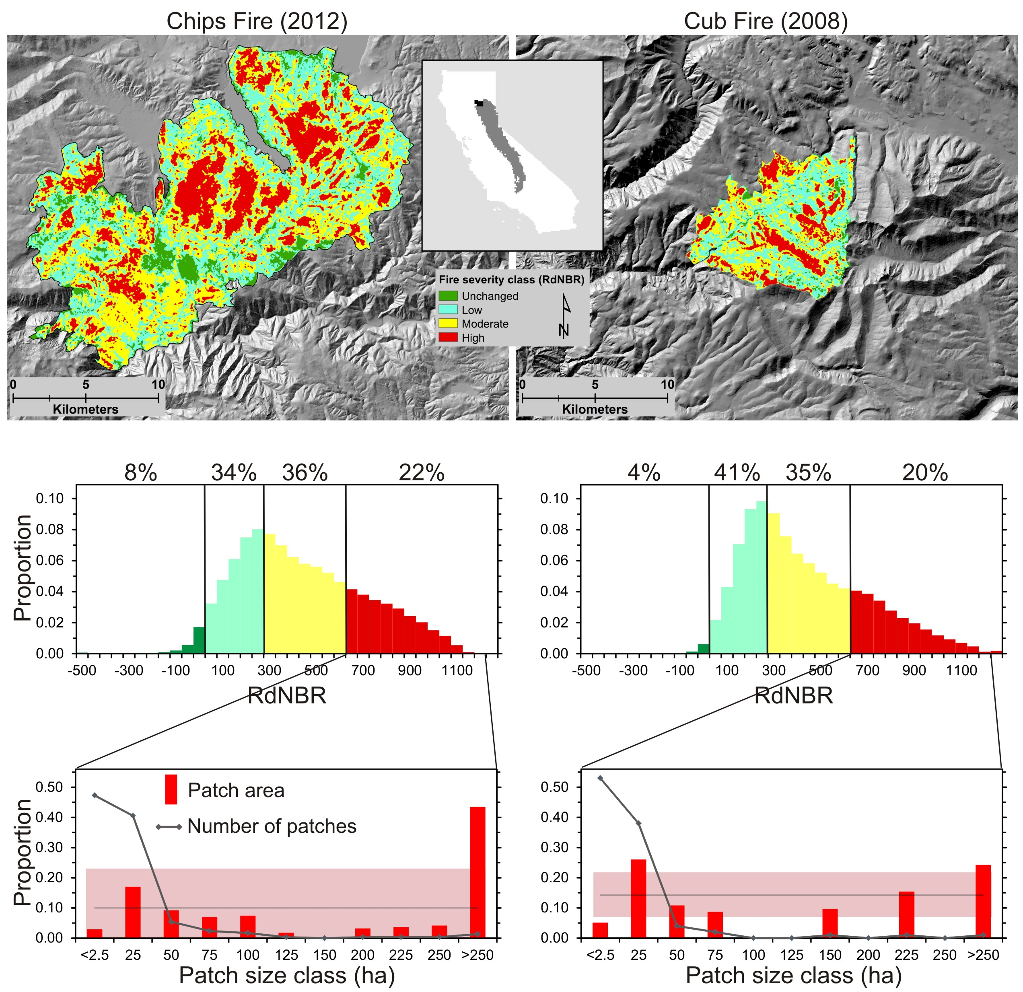

Figure 2.

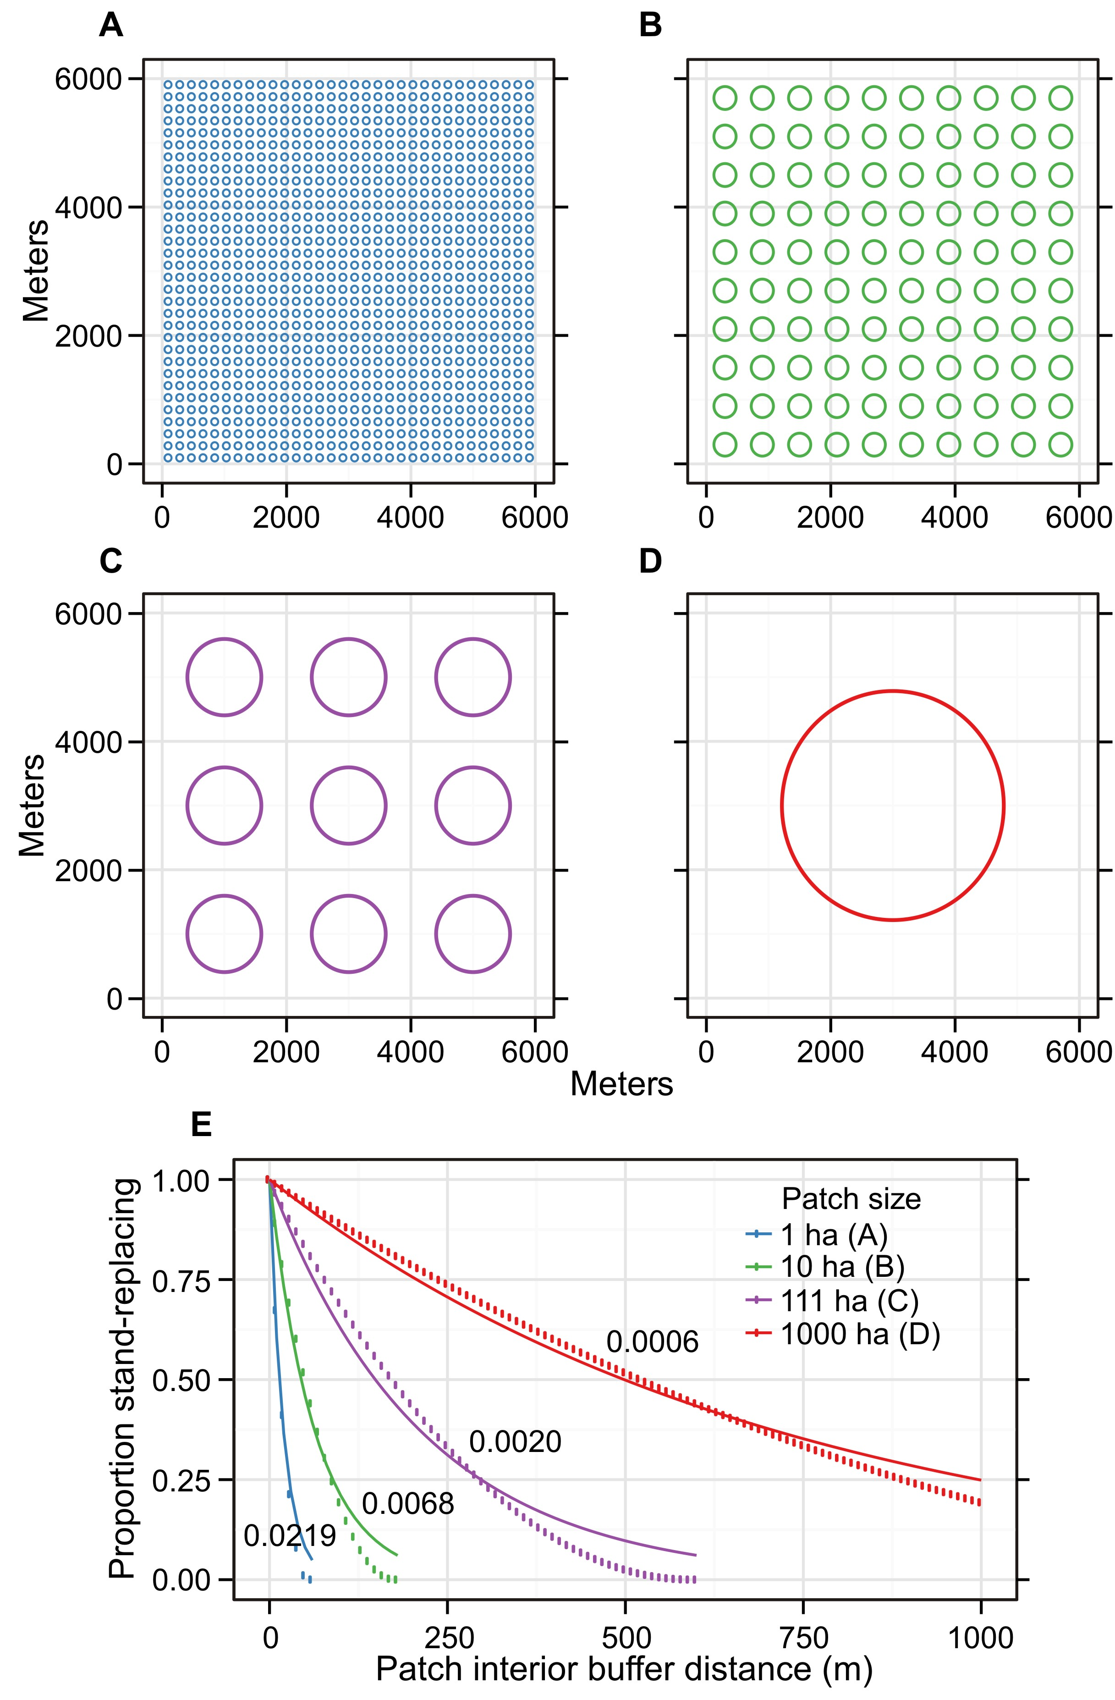

Figure 3

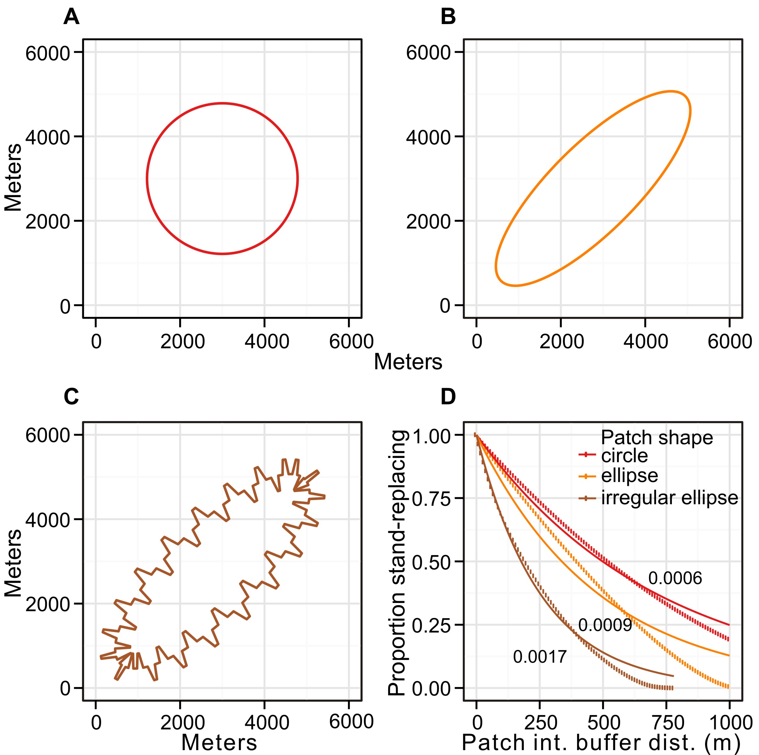

Figure 4.

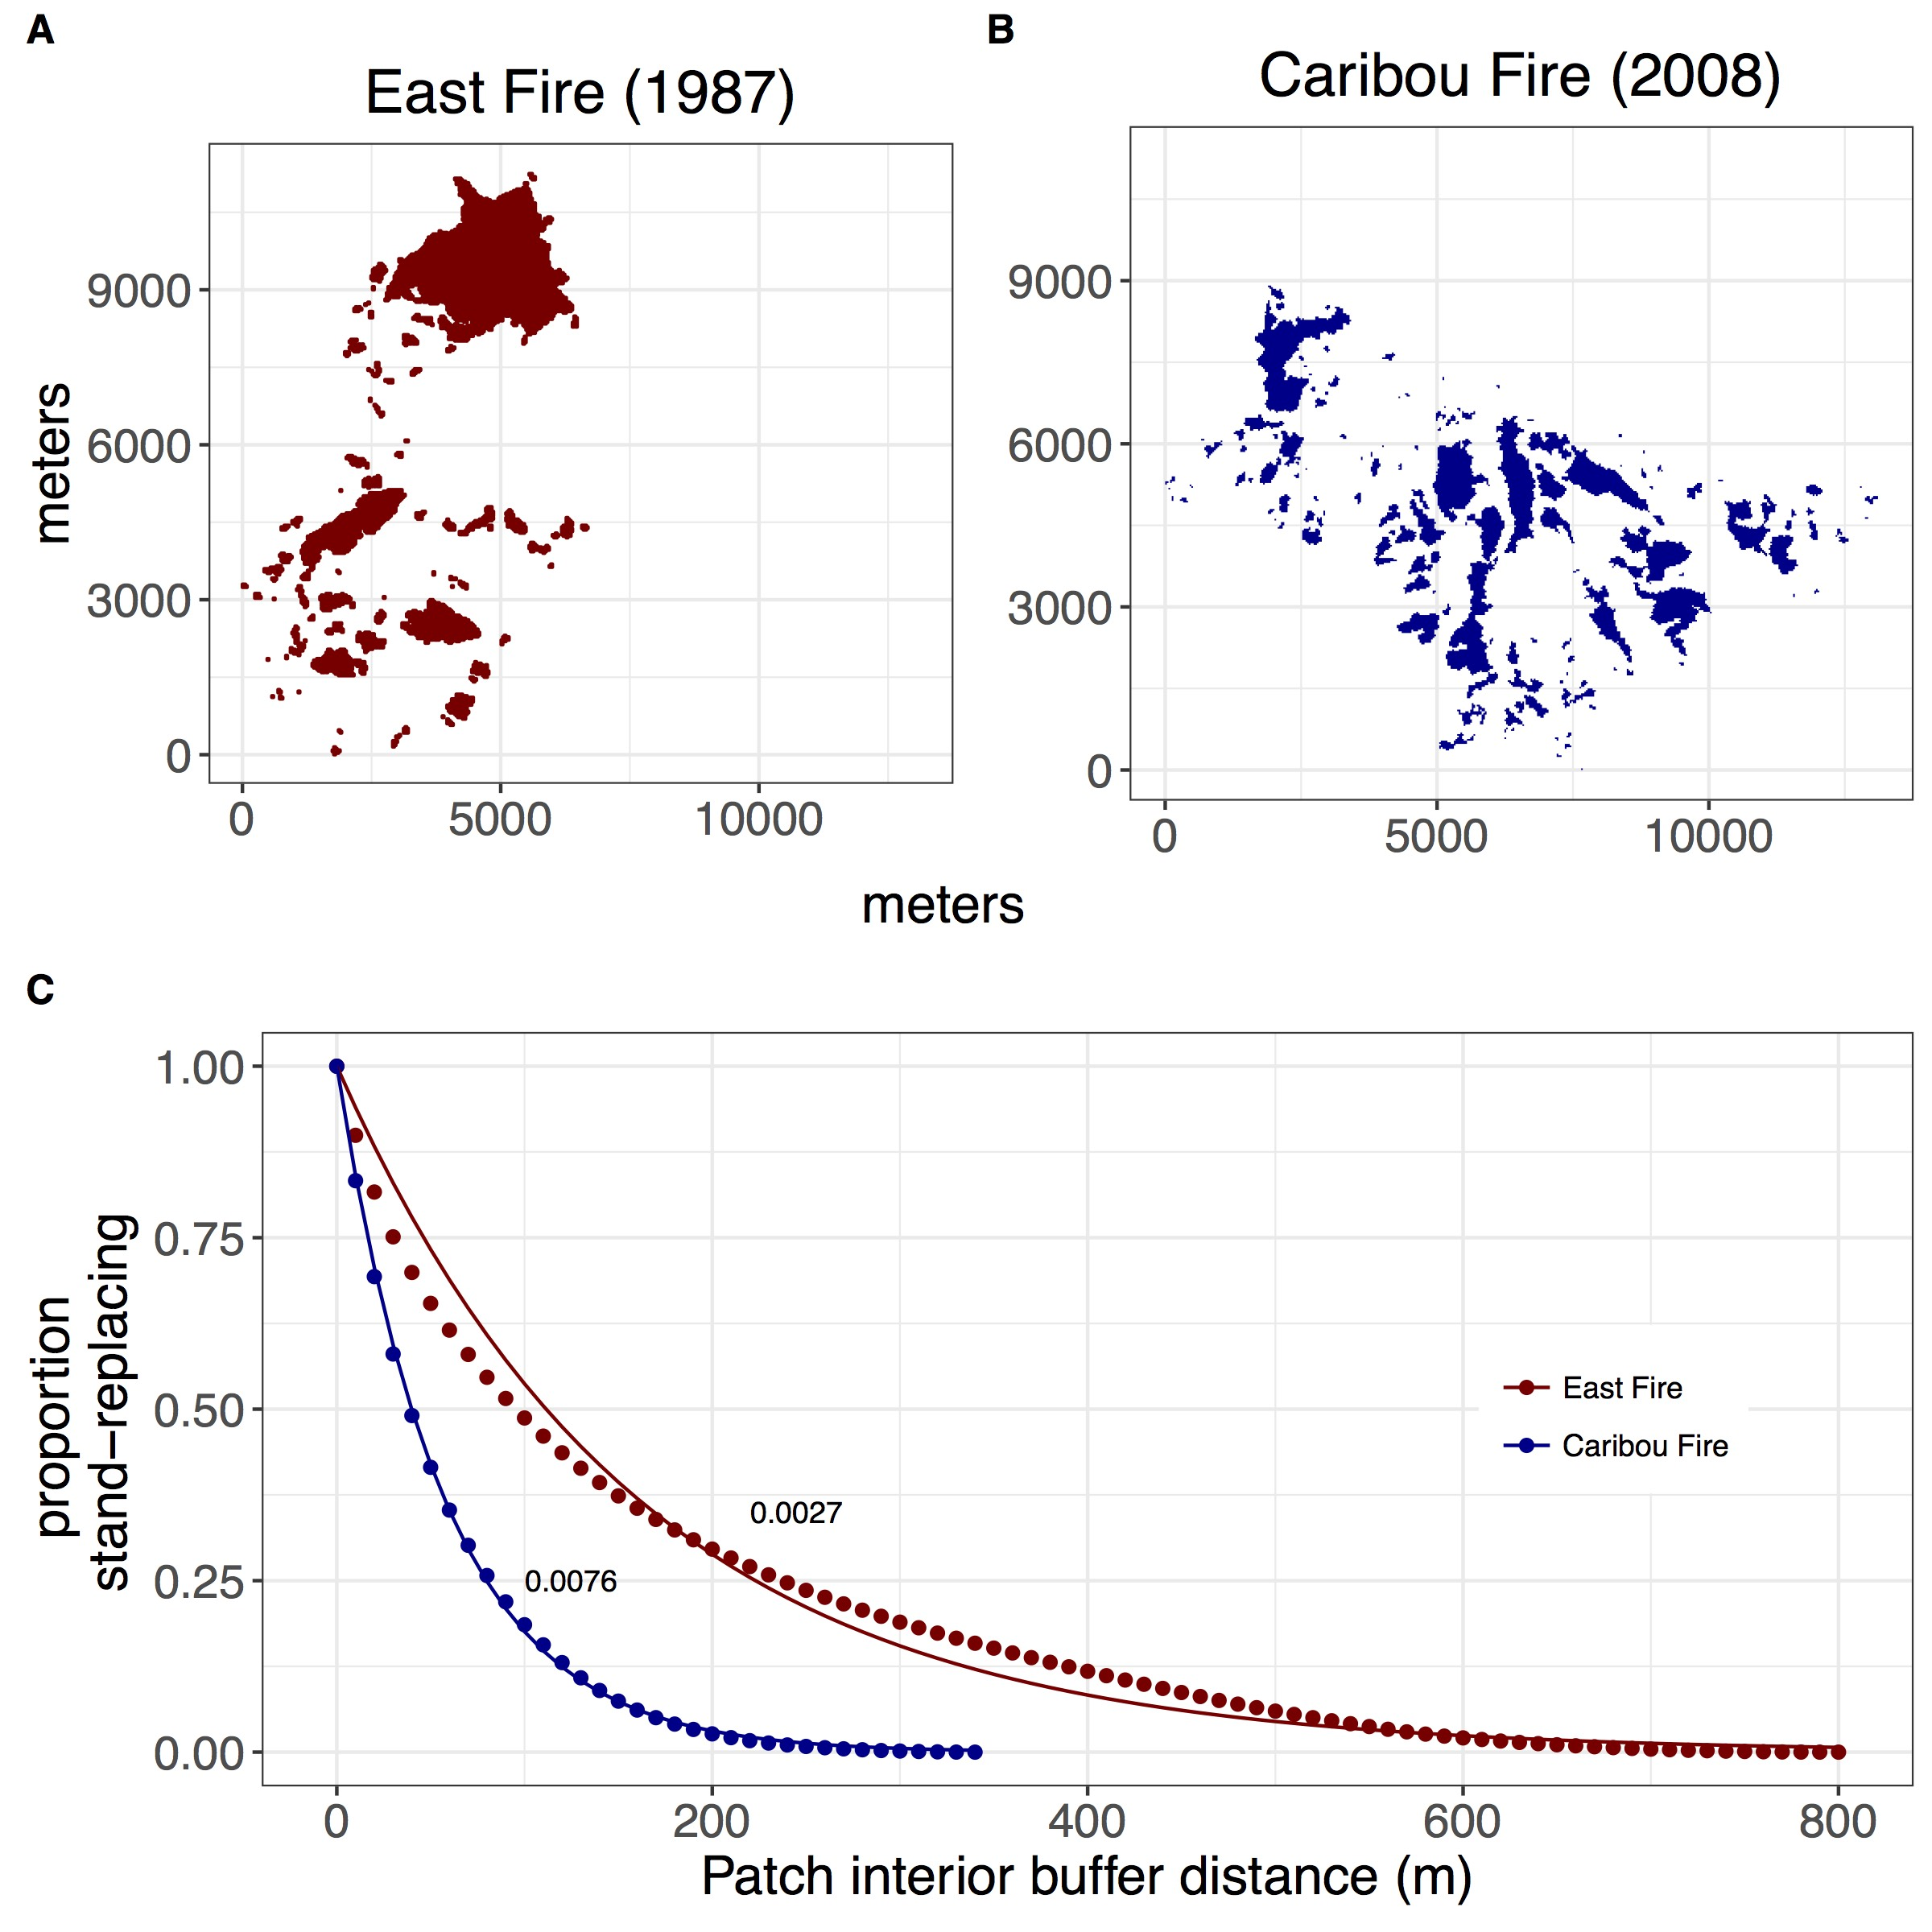

Figure 5.

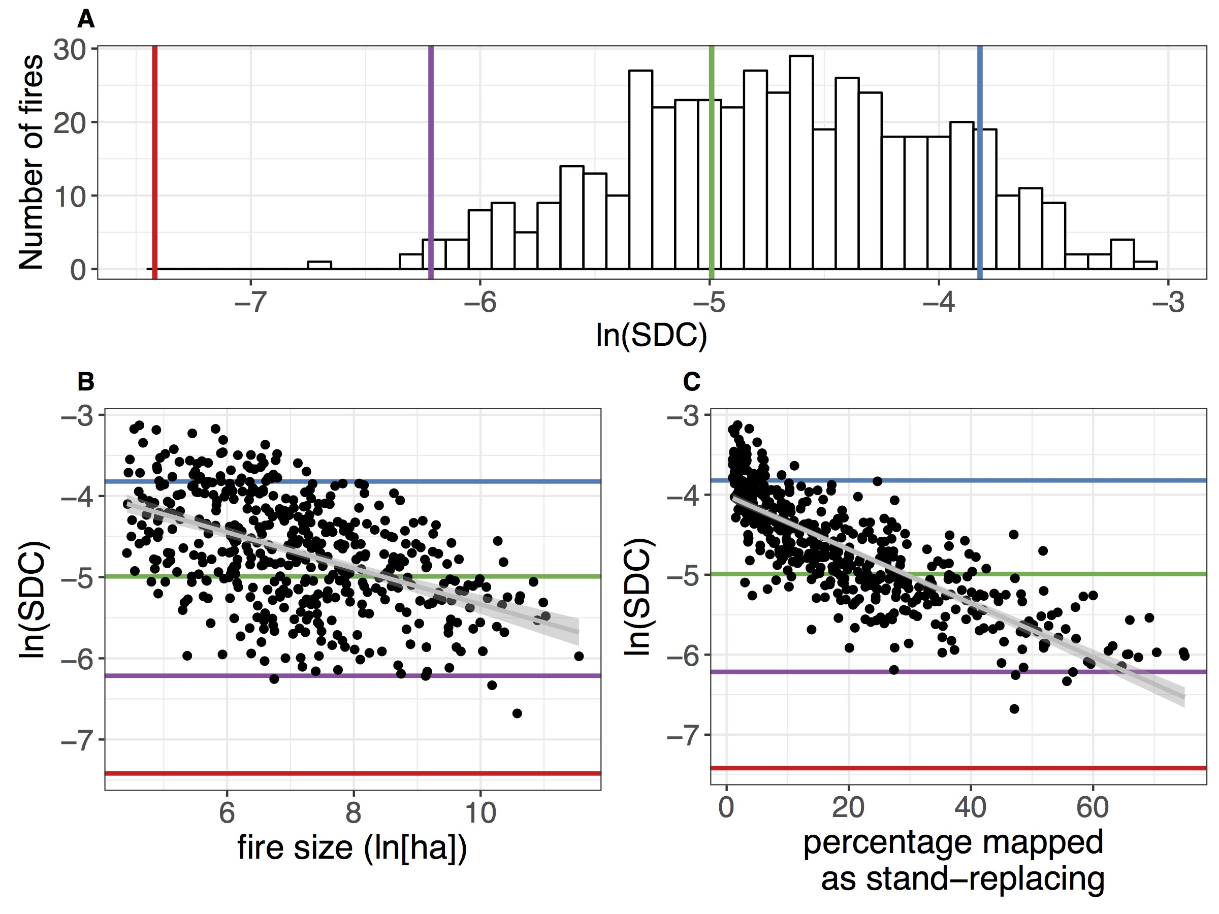

Figure S1. Proportion of stand-replacing patch area within different distance-to-patch-edge classes.

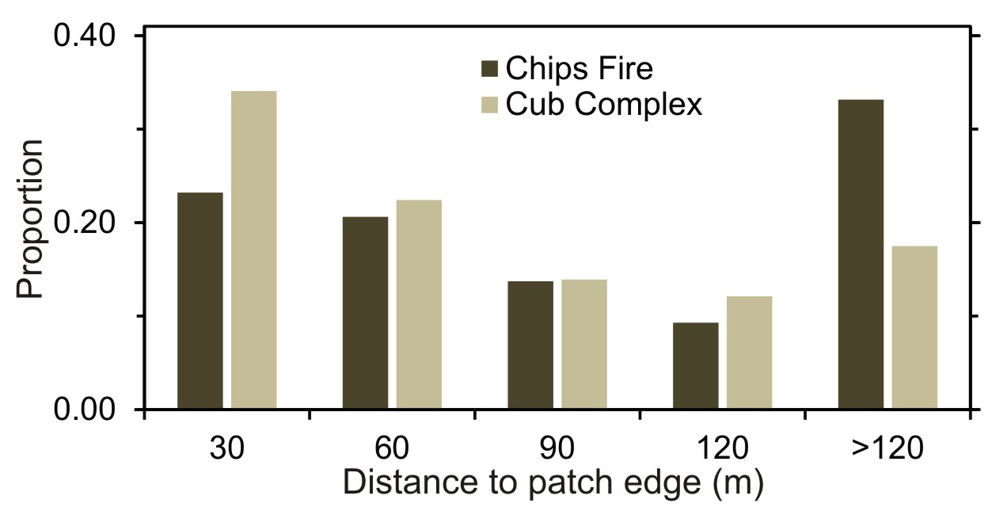

Figure S2. Relationship between SDC and Area-weighted Mean Shape Index (AWMSI, A) and Area-weighted Mean Patch Fractal Dimension (AWMPFD, B) among the 477 sampled fires. Shaded area represents 95% confidence interval on best-fit linear regression line.

